CR-05 - Goals and Outcomes
Progress the jurisdiction has made in carrying out its strategic plan and its action plan. 91.520(a)
This could be an overview that includes major initiatives and highlights that were proposed and executed throughout the program year.

The City pursued all resources that it indicated it would pursue as stated in the Consolidated Plan. The City provided required certifications of consistency for HUD Programs, in a fair and impartial manner, for which the city had indicated in the Consolidated Plan that it would support if such applications were made by other entities including non-profits, and Public Housing Authorities. Additionally, the City did not hinder the implementation of the Consolidated Plan by any action or willful inaction.
The activities funded were used exclusively for one of the three national objectives. None of the activities specified in the One Year Action Plan involved rehabilitation, or demolition, of occupied real property therefore displacement did not occur. Economic Development activities for the City are addressed through the San Benito Economic Development Corporation and CDBG funds are not utilized for such activities at the present time.
No program income was received for the reporting period. Lump sum agreements were not made. Neither Housing Rehabilitation nor Neighborhood Revitalization Strategy Programs were funded using CDBG monies.

Comparison of the proposed versus actual outcomes for each outcome measure submitted with the consolidated plan and explain, if applicable, why progress was not made toward meeting goals and objectives. 91.520(g)
Categories, priority levels, funding sources and amounts, outcomes/objectives, goal outcome indicators, units of measure, targets, actual outcomes/outputs, and percentage completed for each of the grantee’s program year goals.

Goal | Category | Source / Amount | Indicator | Unit of Measure | Expected – Strategic Plan | Actual – Strategic Plan | Percent Complete | Expected – Program Year | Actual – Program Year | Percent Complete
Administration | Administration | CDBG: $ | Other | Other | 1 | 1 | 100.00% | 1 | 0 | 0.00%
Education Objective | Non-Homeless Special Needs  Non-Housing Community Development | CDBG: $ | Public service activities other than Low/Moderate Income Housing Benefit | Persons Assisted | 200 | 16 | 8.00% | 40 | 0 | 0.00%
Infrastructure Objective | Non-Housing Community Development | CDBG: $ | Public Facility or Infrastructure Activities other than Low/Moderate Income Housing Benefit | Persons Assisted | 68600 | 38350 | 55.90% | 13720 | 0 | 0.00%
Public Facilities Objective | Non-Housing Community Development | CDBG: $ | Public Facility or Infrastructure Activities other than Low/Moderate Income Housing Benefit | Persons Assisted | 68600 | 0 | 0.00% | 13720 | 0 | 0.00%
Senior Services Objective | Non-Homeless Special Needs | CDBG: $ | Public service activities other than Low/Moderate Income Housing Benefit | Persons Assisted | 7500 | 10 | 0.13% | 1500 | 0 | 0.00%
Senior Services Objective 2 | Non-Homeless Special Needs | CDBG: $ | Public service activities other than Low/Moderate Income Housing Benefit | Persons Assisted | 200 | 53 | 26.50% | 40 | 0 | 0.00%
Youth Services Objective | Non-Homeless Special Needs | CDBG: $ | Public service activities other than Low/Moderate Income Housing Benefit | Persons Assisted | 200 | 30 | 15.00%
Youth Services Objective 2 | Non-Homeless Special Needs | CDBG: $ | Public service activities other than Low/Moderate Income Housing Benefit | Persons Assisted | 200 | 392 | 196.00% | 10 | 0 | 0.00%
Table 1 - Accomplishments – Program Year & Strategic Plan to Date

Assess how the jurisdiction’s use of funds, particularly CDBG, addresses the priorities and specific objectives identified in the plan, giving special attention to the highest priority activities identified.
The activities undertaken by the City of San Benito during the reporting period address the objectives as set out in the Rio Grande Valley Entitlement Communities Consolidated Plan and Strategy (CPS). Every effort was made to complete projects that addressed the highest priority such as infrastructure improvements, and public services specifically for the youth, elderly and abused. The City of San Benito realizes that the need is much greater than the funding provided. We will continue to address the projects with the highest priority.
Many accomplishments were achieved during the reporting period concerning public facilities and improvements. The successful ongoing street reconstruction project continued to benefit our low to moderate income neighborhoods. This year, a total of approximately 13,720 persons benefited from the improvements made. All of the activities which were undertaken in the Year Five Action Plan directly impacted and benefited low to moderate-income families.

CR-10 - Racial and Ethnic composition of families assisted
Describe the families assisted (including the racial and ethnic status of families assisted). 91.520(a)

 | CDBG
White | 134
Black or African American | 1
Asian | 0
American Indian or American Native | 0
Native Hawaiian or Other Pacific Islander | 0

Total | 135

Hispanic | 131
Not Hispanic | 4

Table 2 – Table of assistance to racial and ethnic populations by source of funds

Narrative
As our CPS indicated there are a great variety of social service agencies that solicit funding from our CDBG program. The number of solicitations for funding far exceeded the 15% that may be allocated to public service activities. Due to the high number of proposals received on an annual basis, the City has continuously funded those agencies that provide the largest impact. Those public service agencies include those that provide assistance to youth, elderly, and abused/neglected children.
For detailed information on project accomplishments, including the number, types of households served, income of those served, and racial and ethnic composition, please refer to the IDIS Report C04PR03.

CR-15 - Resources and Investments 91.520(a)
Identify the resources made available
Source of Funds | Source | Resources Made Available | Amount Expended During Program Year
CDBG | CDBG | 353,367 | 468,446
HOME | HOME
HOPWA | HOPWA
ESG | ESG
Other | Other
Table 3 - Resources Made Available

Narrative
The City of San Benito is an entitlement community of CDBG funds. The allocation amount for 2016-2017 was $353,367 Available is the unexpended CDBG Funds at end of previous program year of $115,079 plus the entitlement grant of $353,367 equals $468,446.

Identify the geographic distribution and location of investments
Target Area | Planned Percentage of Allocation | Actual Percentage of Allocation | Narrative Description
CDBG Eligible Areas | 45 | 100 | Areas eligible for CDBG area benefit.
City-wide | 55 | 100 | City of San Benito
Table 4 – Identify the geographic distribution and location of investments

Narrative
The entitlement funds received by the City of San Benito have historically been designated for qualifying low and moderate-income residents in the City. All census tracts located within the City limits are qualifying low to moderate income areas, city wide, which includes the highest concentration of low/moderate income families. The map attached as an exhibit identifies the city limits and all census tracts within the City of San Benito. The City of San Benito is not funding any specific target projects.

Leveraging
Explain how federal funds leveraged additional resources (private, state and local funds), including a description of how matching requirements were satisfied, as well as how any publicly owned land or property located within the jurisdiction that were used to address the needs identified in the plan.
The City, through its Community Grants and Programs Department, continued to pursue alternative funding for other community development needs in high priority areas.
In 2013, the City obtained one new grant through the University of Texas Health Science Center at San Antonio. This grant, which will run through December 2018, is helping to improve the health of San Benito’s residents through increased physical activity and healthy eating. Our focus is on the underserved and lower-income members of our community. A Community Outreach Worker was hired and continues to offer free classes featuring exercise and health awareness.
We have also partnered with the Texas A&M AgriLife Extension Service and San Benito’s Positive Redirection Center on the creation of two Community Gardens. The first garden is located near our popular Resaca Trail while the second is a low income area in San Benito. Classes continue to be held for beginning garden enthusiasts. Everyone is welcome to plant and care for their vegetables. The Positive Redirection Center also implemented an anti-graffiti program that has helped clean up the city from unsightly graffiti.
The department has also obtained a Recreational trails grant from Texas Parks and Wildlife and a grant to create a park on the South side of the City through the Valley Baptist Legacy Foundation.
The City also received a grant from Texas A&M Agrilife Extension Service. The goal is to pipe treated effluent from the City of San Benito wastewater treatment plant to sustain wetlands and enhance wastewater treatment prior to release into the Arroyo Colorado..

CR-20 - Affordable Housing 91.520(b)
Evaluation of the jurisdiction's progress in providing affordable housing, including the number and types of families served, the number of extremely low-income, low-income, moderate-income, and middle-income persons served.

 | One-Year Goal | Actual
Number of Homeless households to be provided affordable housing units | 0 | 0
Number of Non-Homeless households to be provided affordable housing units | 0 | 0
Number of Special-Needs households to be provided affordable housing units | 0 | 0
Total | 0 | 0
Table 5 – Number of Households

 | One-Year Goal | Actual
Number of households supported through Rental Assistance | 0 | 0
Number of households supported through The Production of New Units | 0 | 0
Number of households supported through Rehab of Existing Units | 0 | 0
Number of households supported through Acquisition of Existing Units | 0 | 0
Total | 0 | 0
Table 6 – Number of Households Supported

Discuss the difference between goals and outcomes and problems encountered in meeting these goals.
Currently, the City of San Benito does not have funding for housing activities, therefore the City did not fund any housing activities for program year 2016. The numbers provided above reflect the housing authority accomplishments. San Benito Housing Authority is providing housing programs through the Housing Choice Voucher Program and Public Housing Program, both funded through the U.S. Department of Housing and Urban Development (HUD). Each year the allocation of these two (2) programs reduces. Thus, making it difficult for SBH to increase the number of households to assist.
The PHA’s public facility – San Benito Housing Development Corporation developed the Stone Village Community. This community housed 40 families of low to moderate incomes; of which 19 families were of very,very low income (30% of AFMI).

Discuss how these outcomes will impact future annual action plans.
The City of San Benito is not a recipient of HOME funds, therefore, housing activities are normally not included in our annual action plans for funding. However, The San Benito Community Grants and Programs department and the PHA jointly strive towards placing low, very low, and low to moderate income families in decent, safe and sanitary affordable homes utiltizing both the Public Housing Program and the Section 8 Homeownership Choice program. The PHA has adopted a policy and can utilize its Secion 8 Voucher Program as mortgage payments for qualified participants. Both the PHA and the City have collaborated in efforts to further the San Benito HOME Program.
The PHA also has an ongoing SBCIDS/SBHA Home Construction Project. This project housed four low to moderate income families during this past fiscal year. The families are all Housing Choice Voucher Program participants and are utilizing their voucher towards homeownership. This program is in its final stages with the final home still pending completion

Include the number of extremely low-income, low-income, and moderate-income persons served by each activity where information on income by family size is required to determine the eligibility of the activity.

Number of Households Served | CDBG Actual | HOME Actual
Extremely Low-income | 0 | 0
Low-income | 0 | 0
Moderate-income | 0 | 0
Total | 0 | 0
Table 7 – Number of Households Served

Narrative Information

CR-25 - Homeless and Other Special Needs 91.220(d, e); 91.320(d, e); 91.520(c)
Evaluate the jurisdiction’s progress in meeting its specific objectives for reducing and ending homelessness through:
Reaching out to homeless persons (especially unsheltered persons) and assessing their individual needs
The City has joined neighboring cities and homeless service providers across Cameron County to develop action steps to prevent and eventually put an end to homelessness through the creation of the Cameron County Homeless Partnership (CCHP). This group actively seeks funding through the Continuum of Care.

Addressing the emergency shelter and transitional housing needs of homeless persons
The City of San Benito is not a recipient of ESG or other McKinney-Vento Homeless Assistance Act Program funds, however, collaboration with the PHA maximizes efforts to maintain services and resources provided to individuals or families who may become homeless. The PHA provides the only support mechanism for homeless families by providing shelter through Public Housing units or Section 8 vouchers and also serves as transitional housing by allowing these families, who would otherwise be homeless, live within the public housing units and eventually become homeowners through various Affordable Housing Programs available through collaborative endeavors. In an effort to promote transition into permanent housing, families residing in Public Housing Developments or participating in Section 8 vouchers are encouraged to become homeowners through the San Benito HOME Program.

Helping low-income individuals and families avoid becoming homeless, especially extremely low-income individuals and families and those who are: likely to become homeless after being discharged from publicly funded institutions and systems of care (such as health care facilities, mental health facilities, foster care and other youth facilities, and corrections programs and institutions); and, receiving assistance from public or private agencies that address housing, health, social services, employment, education, or youth needs
In partnership with the City, the member organizations of the Cameron County Homeless Partnership provide an array of prevention services, including:

· Case Management (limited and short-term assessments and education, and home visits),
- Child abuse assistance (crisis intervention and immediate safety)
- Emergency assistance (overnight vouchers, utility assistance, security and utility deposits, food and clothing distribution, meals, use of shower and restroom facilities, health-related transportation, and referrals),
- Family violence assistance (crisis intervention and immediate safety),
- Information and referral (Info line),
- Life skills classes (counseling center), and
- Tenant counseling, fair housing, discrimination, and housing assistance.

Helping homeless persons (especially chronically homeless individuals and families, families with children, veterans and their families, and unaccompanied youth) make the transition to permanent housing and independent living, including shortening the period of time that individuals and families experience homelessness, facilitating access for homeless individuals and families to affordable housing units, and preventing individuals and families who were recently homeless from becoming homeless again
The City of San Benito is an active supporter of the Cameron County Homeless Partnership and it's strategic plan. Realizing the detrimental effects homelessness has on the health and wellbeing of its residents, the Cameron County Homeless Partnership continues to meet on a regular basis to update their strategic plan to prevent and eventually end chronic homelessness. Made up of representatives from state and local government entities, public housing agencies, school systems, universities, law enforcement agencies, housing organizations, faith-based organizations, advocacy groups, local businesses, hospitals, medical facilities, as well as homeless service providers, the Partnership continues work on creating a seamless flow of services to homeless individuals and families that will create a “sustainable form of livelihood” that can ensure permanent housing meant for human habitation.
The strategies of the Cameron County Homeless Partnership (attached as an exhibit) provide the road map for implementing key strategies in the current year.
During 2016, The City of San Benito received phone correspondence from citizens requesting assistance to install ramps. They stated that the ramps would allow them or their elderly parent’s better access into their home. Due to the fact that San Benito has no funds to assist with the installation of ramps, The City of San Benito referred the citizens to the San Benito Housing Authority and Habitat for Humanity. These concerns prompted the Community Grants and Programs Department to begin to work on a pamphlet that would inform all citizens of the services available to them along with the contact Information.
In 2016, the City of San Benito refurbished several major streets. During the refurbishing process ADA Ramps were installed.
In order to address the needs of the hearing impaired, the City of San Benito contacted Relay Texas. Relay Texas provided guidance in providing services for the hearing impaired. We are now posting the Texas TTY Number in our publications.

CR-30 - Public Housing 91.220(h); 91.320(j)
Actions taken to address the needs of public housing
The City of San Benito is part of the PHA collaborative partnership for public housing needs. The Housing Authority of the City of San Benito continues to budget funds from the Capital Fund Program to renovate and update public housing units throughout the community. Through its residents initiative services, public housing residents received valuable resources in education of nutrition, child care, and other preventive measures of family issues. Through collaborative partnerships, other resources were made possible to the families ranging from child care, early childhood education, and youth recreational activities.
The PHA is the lead agency in all of the community housing programs, such as the First-Time Homebuyer Program and the Owner Occupied Rehabilitation Program. The PHA also offers the Section 8 Home Choice Voucher which aids the family with the mortgage payments. All of these programs operate under the San Benito HOME Program.

Actions taken to encourage public housing residents to become more involved in management and participate in homeownership
The City of San Benito is part of the PHA collaborative partnership to encourage public housing residents to become more involved in management and participate in homeownership. The San Benito Community Grants and Programs department and the PHA jointly strive towards placing low, very low, and low to moderate income families in decent, safe and sanitary affordable homes utilizing both the Public Housing Program and the Section 8 Voucher Homeownership Choice Program. The PHA has adopted a policy and can utilize its Section 8 Voucher Program as mortgage payments for qualified participants. Both the PHA and the City have collaborated in efforts to further the San Benito HOME Program. SBH encourages public housing residents to engage in the current and active Resident Advisory Board. Public Housing residents are also encourgaged to attend monthly meetings of the SBH Board of Commission.

Actions taken to provide assistance to troubled PHAs
The only PHA in San Benito is the Housing Authority of the City of San Benito. Fortunately, this agency is not considered to be a troubled PHA.

CR-35 - Other Actions 91.220(j)-(k); 91.320(i)-(j)
Actions taken to remove or ameliorate the negative effects of public policies that serve as barriers to affordable housing such as land use controls, tax policies affecting land, zoning ordinances, building codes, fees and charges, growth limitations, and policies affecting the return on residential investment. 91.220 (j); 91.320 (i)
In an effort to affirmatively further fair housing, the City of San Benito conducted an assessment of Fair Housing with the participation of local bankers and non-profit organizations. Comments received during that assessment period included: 1) the need to educate the community. 2) the coordination of all housing programs by encouraging the efforts of nonprofit groups, public agencies and the private sector. The overall assessment of the City of San Benito’s current public and private fair housing program and activities is that it is in general, an acceptable program. The City has made every effort to eliminate barriers to affordable housing and to further provide fair housing ordinances and practices to encourage and facilitate an environment of fair housing for all our citizens. The City continues to work with local agencies to develop programs to meet the needs of the community to address the impediments identified. Such actions include participation in Fair Housing Fairs, distribution and placement of posters advocating Fair Housing requirements at various locations throughout the City. Two Public Forums and Stakeholder Focus Group sessions were held at the San Benito Municipal Building to obtain public input for developing the 2015 Analysis of Impediments to Fair Housing Choice. Attendees were gathered through email invitations sent to select resident and community leaders, organizations, industry professionals, public service providers, and public officials. A public meeting notice was published in the San Benito News as well as well as on the department’s Facebook page. General issues related to the housing market, neighborhood conditions, community development needs and concerns pertaining to fair housing choice were discussed during the meeting. Interaction between the agencies and organizations involved continued with impromptu meetings throughout the year. Housing issues were discussed between the City and the San Benito Housing Authority. The Planning Department, Building Inspection Department, and developers continuously meet to address development in San Benito (which is considered an Economically Distressed Area). The City did not receive any complaints or comments on project funding, fair housing choices, or impediments to fair housing. Additionally, there are no cases in San Benito where the Secretary has issued a charge of (or made a finding of) discrimination regarding the existence of fair housing complaints or compliance reviews. To our knowledge, there are no current or pending fair housing discrimination suits filed against the City of San Benito by the Department of Justice or private plaintiffs. of San Benito The Mayor, Celeste Sanchez, presented a proclamation on April 2015, proclaiming the month of April, 2015, as Fair Housing Month. San Benito Housing Authority Board President, Ron Rogers, received the Proclamation along with the Mayor and Commissioners who were also in attendance.

Actions taken to address obstacles to meeting underserved needs. 91.220(k); 91.320(j)
San Benito attempts to expend public funds in a manner that meets local needs—particularly among low- and moderate-income families and individuals—while addressing the RGVECs’ common priorities. This process helps ensure that the San Benito Community Grants and Programs makes the most significant impact according to the issues brought forward by public agencies, community organizations, and residents during the community-wide consultation and citizen participation process. Additionally, the City continues to direct its scarce resources toward projects that will leverage the commitment of other public and private sector support whenever possible.

Actions taken to reduce lead-based paint hazards. 91.220(k); 91.320(j)
The City of San Benito is part of the PHA collaborative partnership to reduce lead-based paint hazards. The San Benito HOME Program (administered by our local PHA) , performs inspections on all existing homes where federal dollars will be utilized, including homes constructed prior to 1978, for lead-based paint. The Housing Authority of the City of San Benito (PHA) has addressed lead based paint hazards in all of its housing units. The PHA's Section 8 Voucher Program continues to address this issue by also performing physical inspections of participating housing units. Special care is given in addressing Lead Based Paint in homes being rehabilitated using OCC funds.

Actions taken to reduce the number of poverty-level families. 91.220(k); 91.320(j)
The City’s Anti-Poverty Strategy focuses on the most vulnerable population segments: very low-income households; those individuals in public or assisted housing; and the uncounted homeless individuals and families. Very low-income households are generally more threatened with homelessness, often living paycheck to paycheck with financial ruin being no more than one unexpected financial setback away. Persons in public or assisted housing are dependent upon public subsidies to maintain their own residences and have just a little more peace of mind and security than their counterparts that are not residents of public housing. In all, these segments of the population have the highest incidence of poverty and possess limited economic enrichment opportunities. These households will see the most immediate benefit from a concentrated effort to increase economic opportunities for all households in the City.
It is important to recognize that the Anti-Poverty Strategy is not a housing plan; it is an economic development plan that attempts to increase incomes and job opportunities for low-income households. The changing and expanding City economy has led to a growth in the number of low as well as high-paying jobs. Nonetheless, housing is a major component of the Plan, since a secure and affordable residence allows household members to pursue jobs education and training without having to worry about the threat of homelessness.
At the core of any economic development plan must be the existence of an infrastructure capable of sustaining the needs of business. Infrastructure in terms of roads, drainage, water and sewer services can be costly line items for any new business development considering relocating or expanding their operations within the City. With this in mind, the City’s community development efforts have had a strong emphasis in developing and sustaining the region’s infrastructure not just for the use and convenience of residents but also as a manner to attract and maintain business opportunities. During the 2016-2017 program year, infrastructure projects make up for over 75% of the CDBG budget programming.
The City further recognizes the need to develop and train its workforce. During the SBCGP’s consultation process, it was discovered that the majority of the local Workforce Development Board operating budget funds are earmarked for low-income persons to place them in a structured institutional setting for skills training or in an on-the-job training setting where employment skills can be taught first-hand. The City’s role then becomes that of a facilitator to bring together all stakeholders with the common interest of addressing the plight of its less fortunate residents. These stakeholders, combined address all areas along the road to self-sufficiency, including childcare, transportation services, community development, housing employment/skills training, educational institutions social service institutions and local government. In light of dwindling resources across the entire spectrum of social services, the answer lies in redefining the role of government in such a way that it fosters the cooperation of different social service programs with the end goal of allowing an individual the opportunity for self sufficiency.

Actions taken to develop institutional structure. 91.220(k); 91.320(j)
The San Benito Grants and Programs department works with a variety of organizations involved in the delivery of housing, homeless, non-homeless special needs, and community development activities- including many of the public agencies and community organizations consulted during the development of the CPS and the One-Year Action Plan. These include Public Housing Authorities (PHA), and community organizations whose fields of interest and services include but are not limited to: social services, youth services, elderly services, disability services, HIV/AIDS services, abused children’s services, health services, homeless services, and domestic violence assistance.
The strength of the City’s institutional structure is derived from the variety of public agencies and community organizations in the area that are working diligently toward one common goal: to provide affordable housing, supportive services, and community development assistance to benefit low-and moderate-income individuals and families. Local agencies, community-based organizations, and social service providers must coordinate their activities in response to the City’s urgent needs.
Each stakeholder in the delivery system contributes valuable resources and expertise.
Furthermore, the City recognizes that the need for affordable housing surpasses its own ability to meet current demand. As such, the City provides letters of support for other affordable housing providers and entities seeking low-income housing tax credits-provided the project is deemed to have merit and is consistent with housing strategy set forth in the RGVEC’s Five-Year Consolidated Plan and Strategy.

Actions taken to enhance coordination between public and private housing and social service agencies. 91.220(k); 91.320(j)
The San Benito Grants and Programs Department coordinates its activities with a variety of organizations involved in the delivery of housing, homeless, non-homeless special needs, and community development activities—including many of the public agencies and community organizations consulted during the development of the CPS and the One-Year Action Plan. They include designated Public Housing Authorities (PHAs), and other community organizations whose fields of interest and service include but are not limited to: social services, youth services, elderly services, disability services, HIV/AIDS services, abused children’s services, health services, homeless services, and domestic violence assistance.
To strengthen this delivery system, the SBCGP has undertaken a more collaborative approach to develop a common vision for housing and community development activities for the South Texas region. Commitment and coordination among different levels of local government, community organizations, and the public will be essential.

Identify actions taken to overcome the effects of any impediments identified in the jurisdictions analysis of impediments to fair housing choice. 91.520(a)
The City works with local agencies to develop programs to meet the local needs of the community and to address the impediments identified. Such actions include participation in Fair Housing Fairs, distribution and placement of posters advocating Fair Housing requirements at various locations throughout the City. The City of San Benito strives to meet with the Housing Authority of the City of San Benito throughout the year to discuss housing issues and needs of the community. In addition, the Planning Department continuously provides technical assistance to developers interested in developing affordable and low-income housing within the jurisdiction.

CR-40 - Monitoring 91.220 and 91.230
Describe the standards and procedures used to monitor activities carried out in furtherance of the plan and used to ensure long-term compliance with requirements of the programs involved, including minority business outreach and the comprehensive planning requirements
Monitoring is an ongoing process involving continuous subrecipient communication and evaluation. The process involves frequent telephone contacts, written communication, periodic meetings, as well as program and activity evaluations. The goal of monitoring is to identify deficiencies and promote corrective action in order to improve and reinforce subrecipient performance.
A desk review of all pertinent project information and documentation is performed. The Community Grants and Programs Coordinator reviews the project file and associated documentation to determine the project’s progress and adherence with the proper regulations. After the desk review is completed, an on-site review of the project is scheduled. This process enables the City to verify the status of the project as suggested in the project file.
It is the City of San Benito’s intent to formally monitor each activity undertaken with HUD entitlement funds at least once yearly. The staff member performs a formal monitoring visit. The purpose of the monitoring process is to determine compliance with the executed contract/subrecipient agreement, HUD requirements, other applicable Federal requirements, and applicable State codes and statutes. The monitoring process also provides an opportunity by which aspects of exemplary project administration or performance are identified.
Pre- and post-interviews are also conducted with subrecipient personnel. These interviews serve two functions: one is to inform the subrecipient of the monitoring goals and purpose; the other is to articulate any areas of concern prior to dissemination of the formal written report as well as to acknowledge areas of good performance. The formal written report is routed to the Community Development Coordinator for review and consent prior to distribution. A copy of the report is then mailed to the appropriate parties. Typically, the City allows a 30-day response timeframe for each report. In addition to the formal monitoring process outlined above, the City monitors the day to day operations of assigned projects continuously. This is accomplished through frequent telephone contacts, written correspondence, e-mails, meetings, and monthly progress report reviews.
During this reporting year, Community Development Staff conducted monthly and annual desk reviews on all public services activities funded in 2016-2017 as CDBG Subrecipients. The City’s annual on-site monitoring reviews revealed that all Subrecipients were making diligent efforts to comply with Federal, State, and local law. Although City Staff found several areas in need of technical assistance, no formal findings were made.
A copy of our Citizen Participation Plan is being submitted as an Exhibit to this report.

Citizen Participation Plan 91.105(d); 91.115(d)
Describe the efforts to provide citizens with reasonable notice and an opportunity to comment on performance reports.
In accordance with its citizen Participation Plan, the City of San Benito, Community Grants and Programs Department, published a notice in the local newspaper (San Benito News) in both English and Spanish, on November 30, 2017 providing for a Public Hearing and allowing the public to comment on the City of San Benito’s 2016-2017 Consolidated Annual Performance and Evaluation Report (CAPER). No public comments have been received. The Public Hearing for comments was also held on December 18, 2017 where no public comments were made or submitted.
To encourage participation of citizens, the time of the public hearing was such that those wanting to attend would most likely be able to without requesting time off from work. The public hearing was held in a public building that is familiar to the public and easily accessible, compliant with ADA, and is convenient for citizens, including persons with disabilities.
The comment period allowed those unable to attend the Public Hearing sufficient time to submit comments via telephone or in writing.
Draft copies of the CAPER were made available during a 15 day comment period, beginning on November 30, 2017 and ending December 28, 2016, at the following location:
- Office of Community Grants and Programs 400 N. Travis Street, San Benito, Texas 78586

CR-45 - CDBG 91.520(c)
Specify the nature of, and reasons for, any changes in the jurisdiction’s program objectives and indications of how the jurisdiction would change its programs as a result of its experiences.
Limited resources have forced us to save funds from one year to another in order to produce a considerable project for our community. In the past, efforts have been made to obtain additional grants and funds. Unfortunately, the City has not been very successful in doing so. City officials have considered the hiring of a Grant writer to help the City with its efforts. However, because resources are scarce the ability to fund such a position has not been realized. The City continues, however to make efforts with its existing staff. As of October 1, 2013, the City restructured the Community Development department into the Community Grants and Programs Department and additional duties have been assigned. During the 2016-2017 Program Year, the City of San Benito did not experience any changes in our program objectives.

Does this Jurisdiction have any open Brownfields Economic Development Initiative (BEDI) grants?
No
[BEDI grantees] Describe accomplishments and program outcomes during the last year.

CR-45 - CDBG 91.520(c)
Specify the nature of, and reasons for, any changes in the jurisdiction’s program objectives and indications of how the jurisdiction would change its programs as a result of its experiences.
Limited resources have forced us to save funds from one year to another in order to produce a considerable project for our community. In the past, efforts have been made to obtain additional grants and funds. Unfortunately, the City has not been very successful in doing so. City officials have considered the hiring of a Grant writer to help the City with its efforts. However, because resources are scarce the ability to fund such a position has not been realized. The City continues, however to make efforts with its existing staff. As of October 1, 2013, the City restructured the Community Development department into the Community Grants and Programs Department and additional duties have been assigned. During the 2016-2017 Program Year, the City of San Benito did not experience any changes in our program objectives.

Does this Jurisdiction have any open Brownfields Economic Development Initiative (BEDI) grants?
No
[BEDI grantees] Describe accomplishments and program outcomes during the last year.

Attachment
Citizens Participation Plan
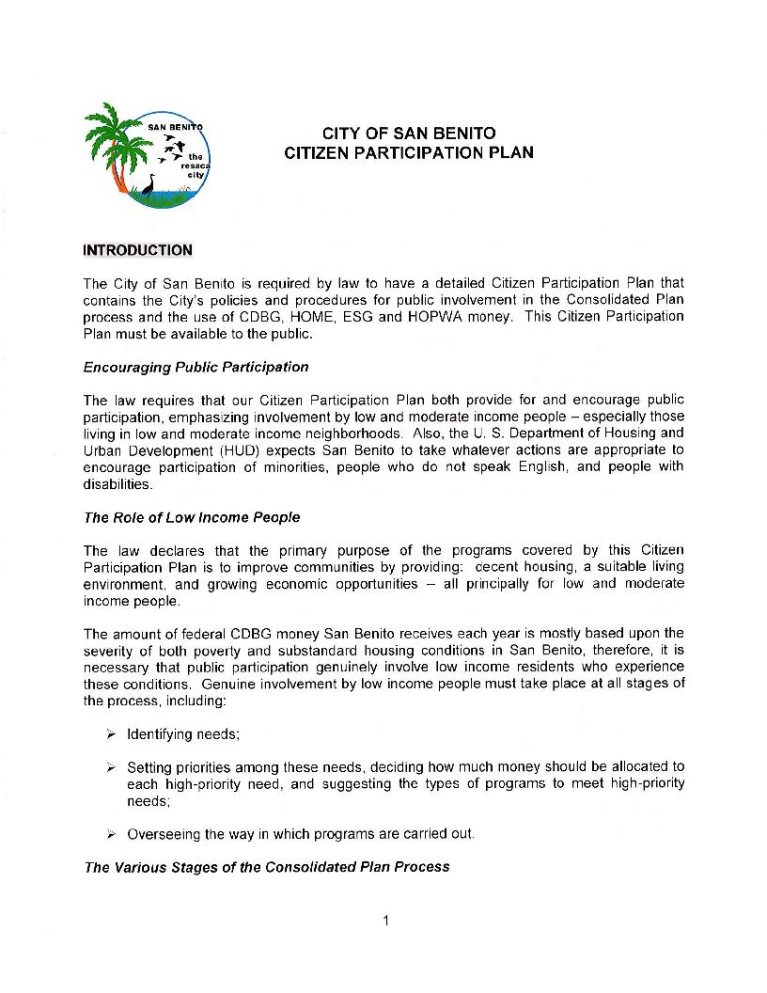
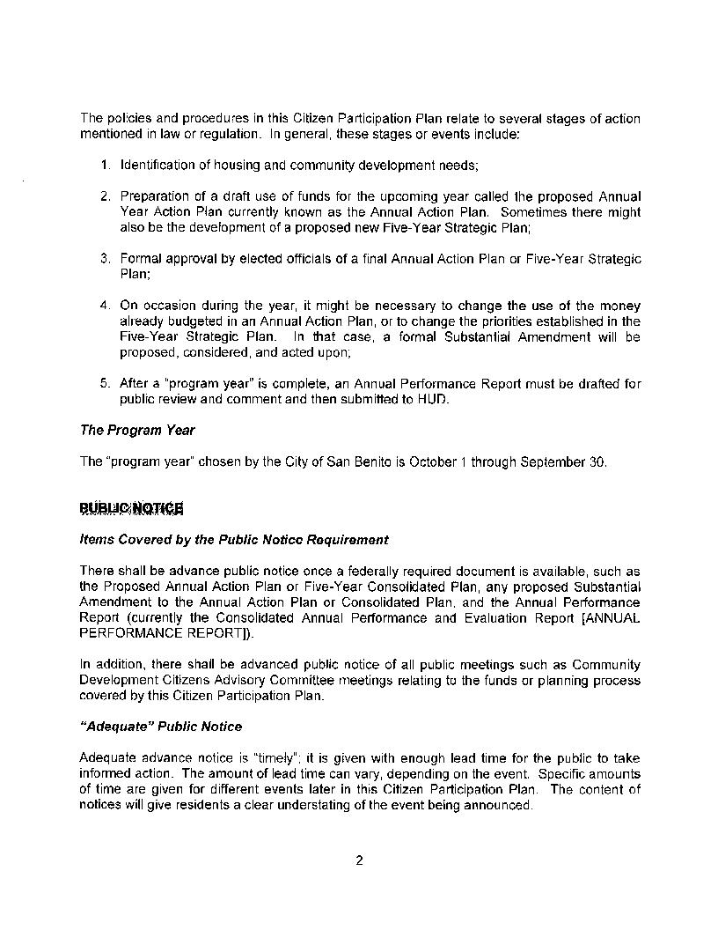
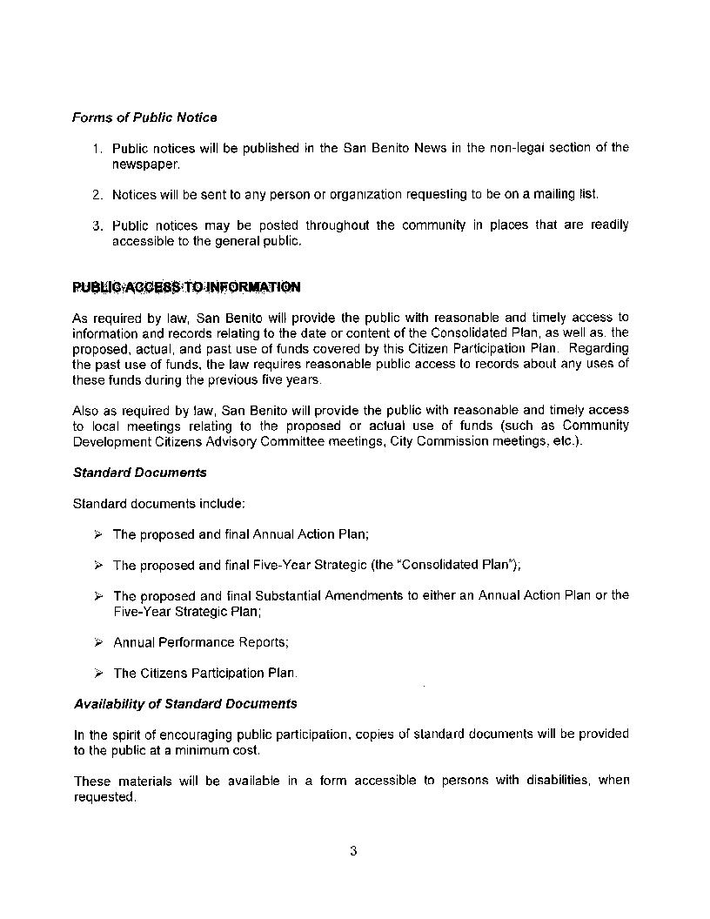
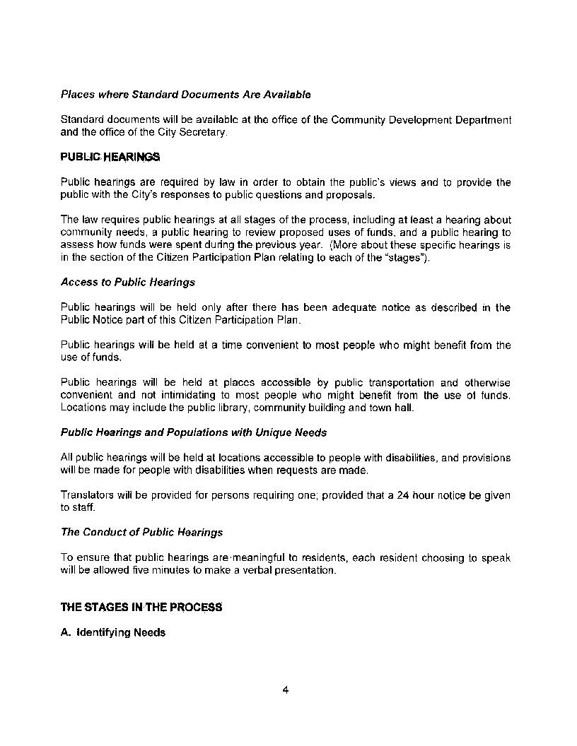
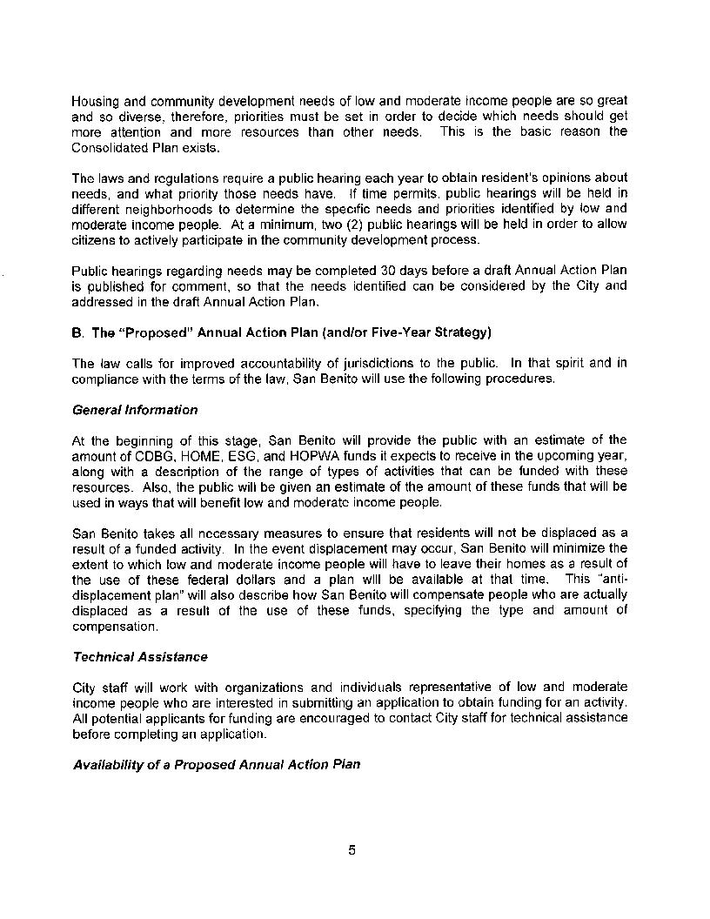
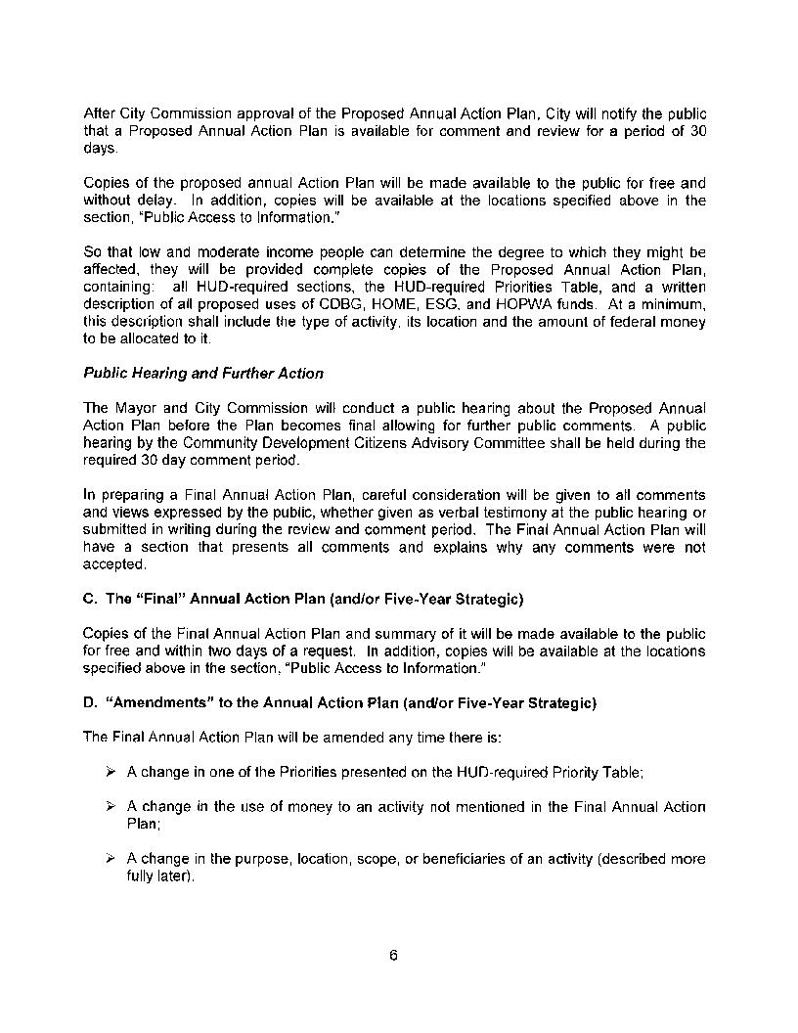
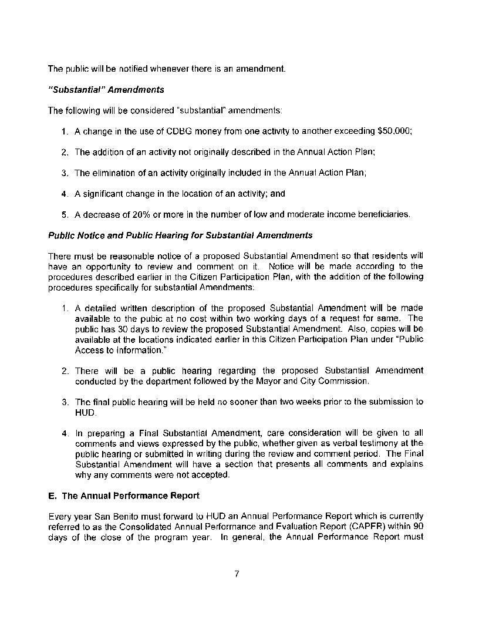
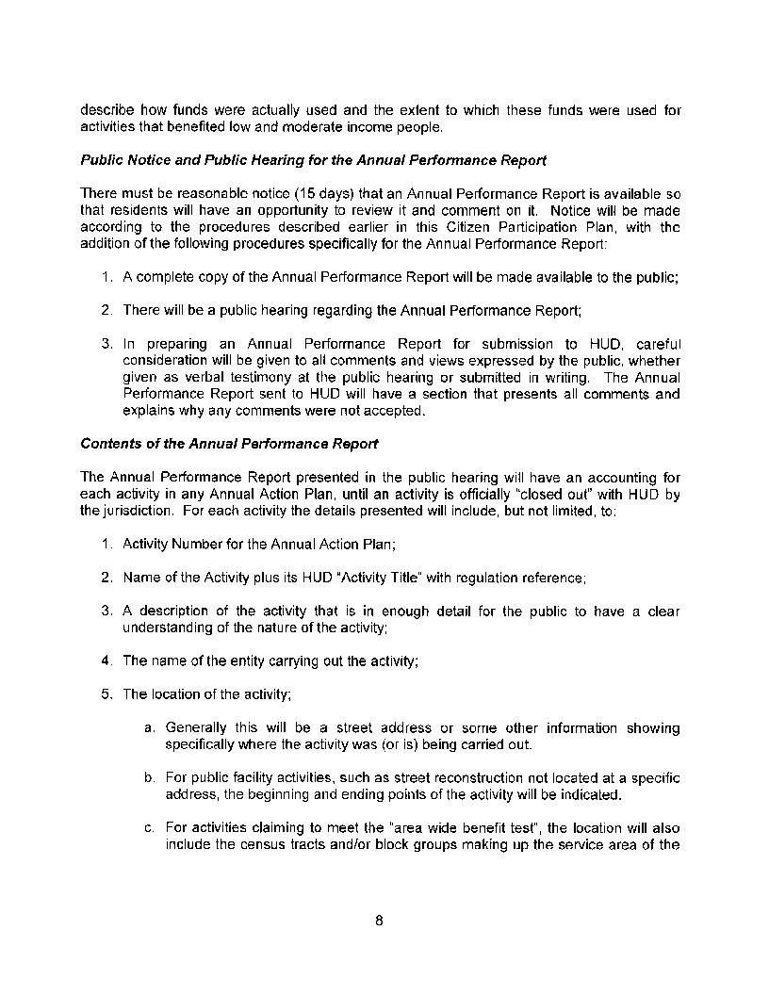
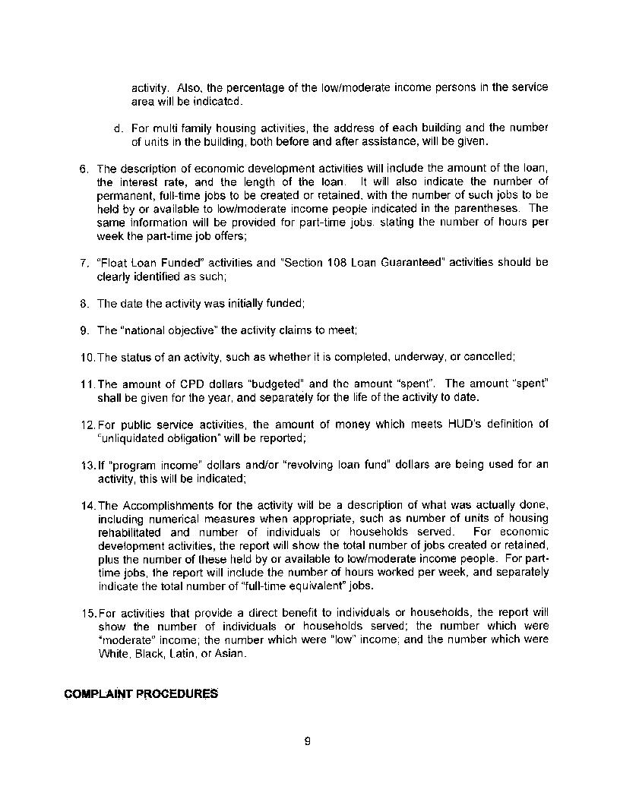
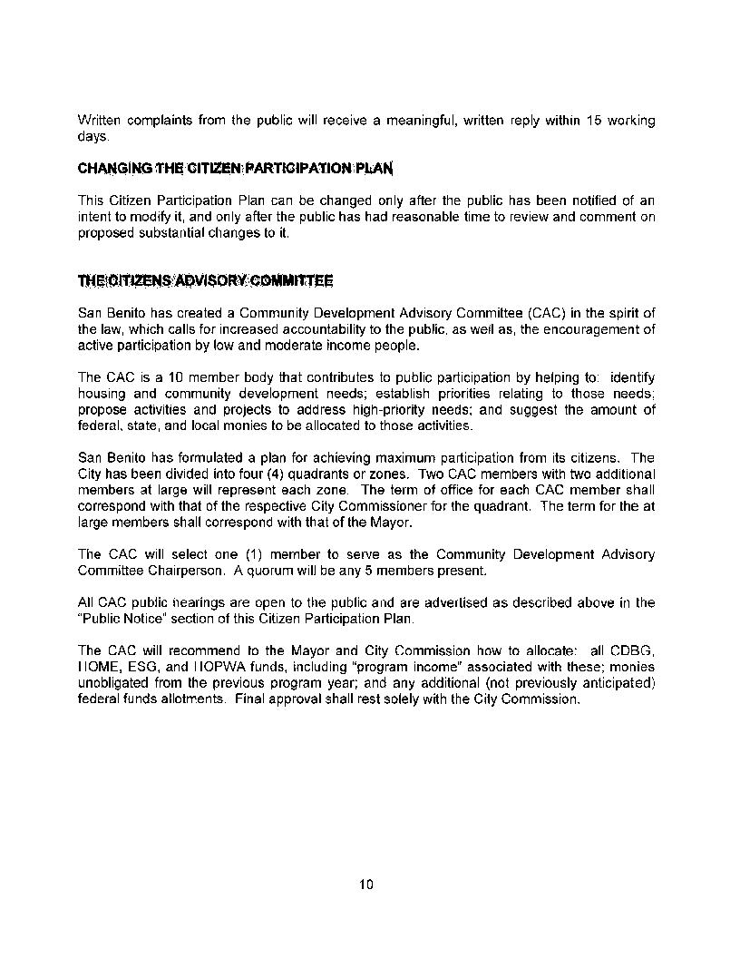

LOCCS and PR26
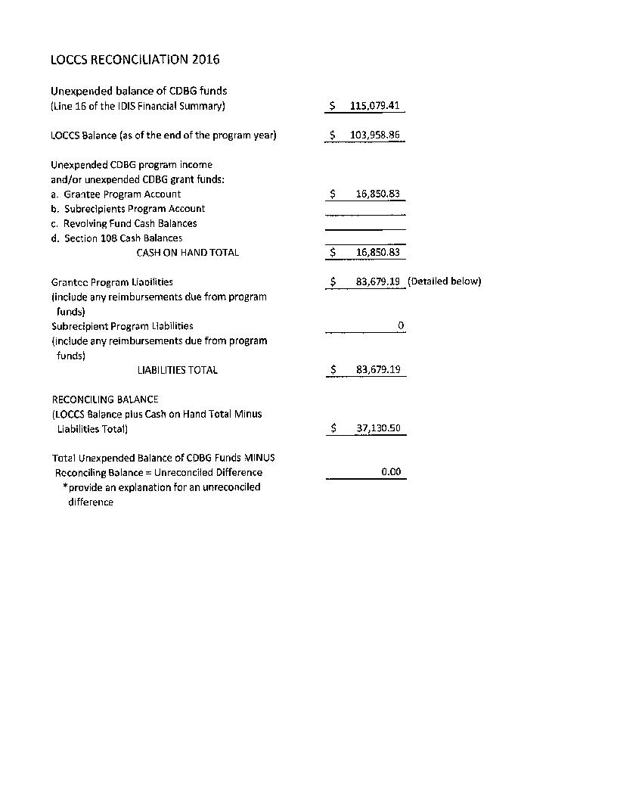
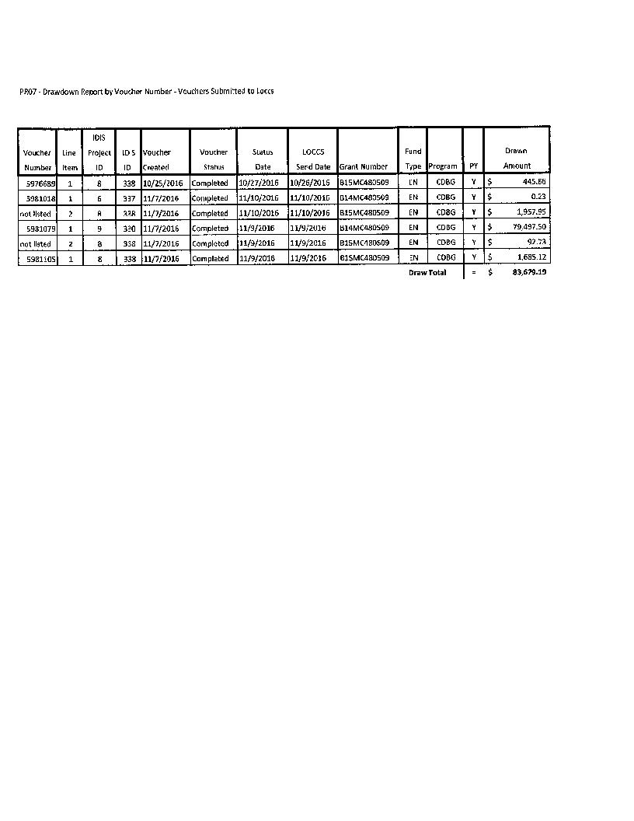
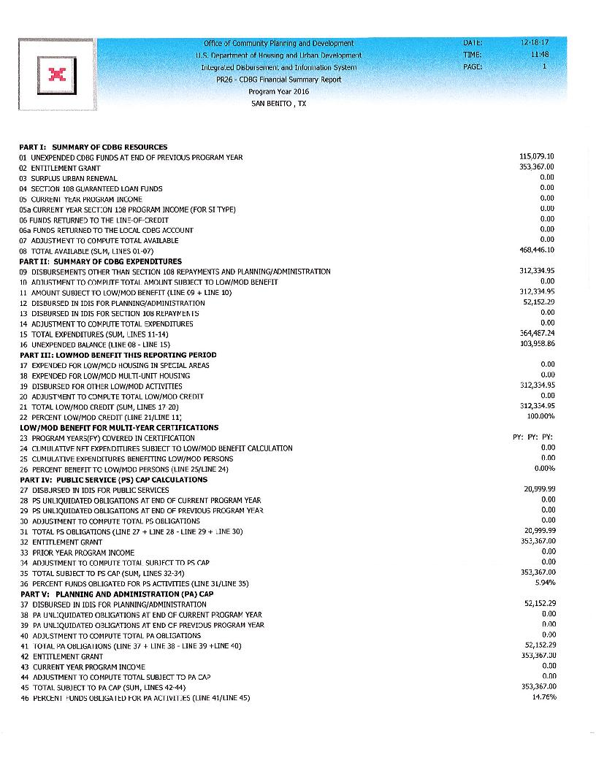
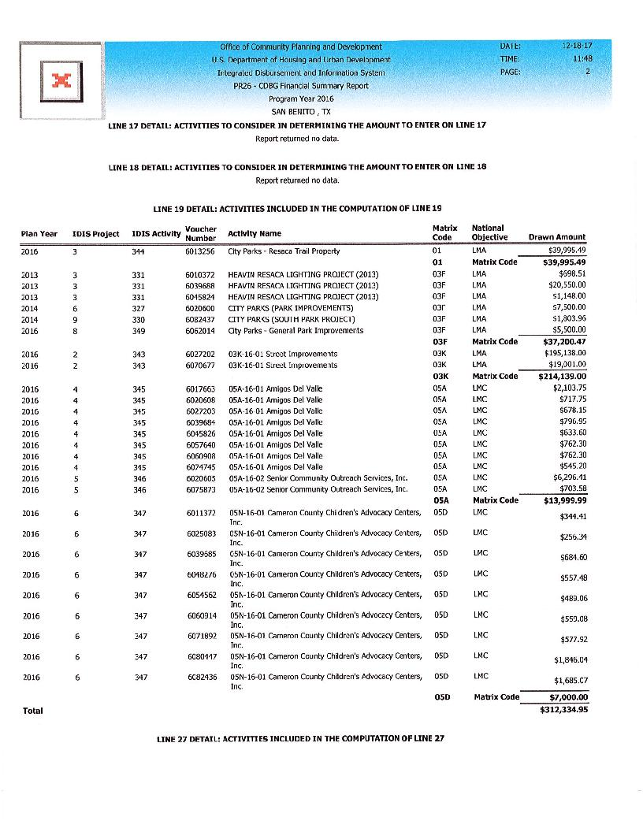
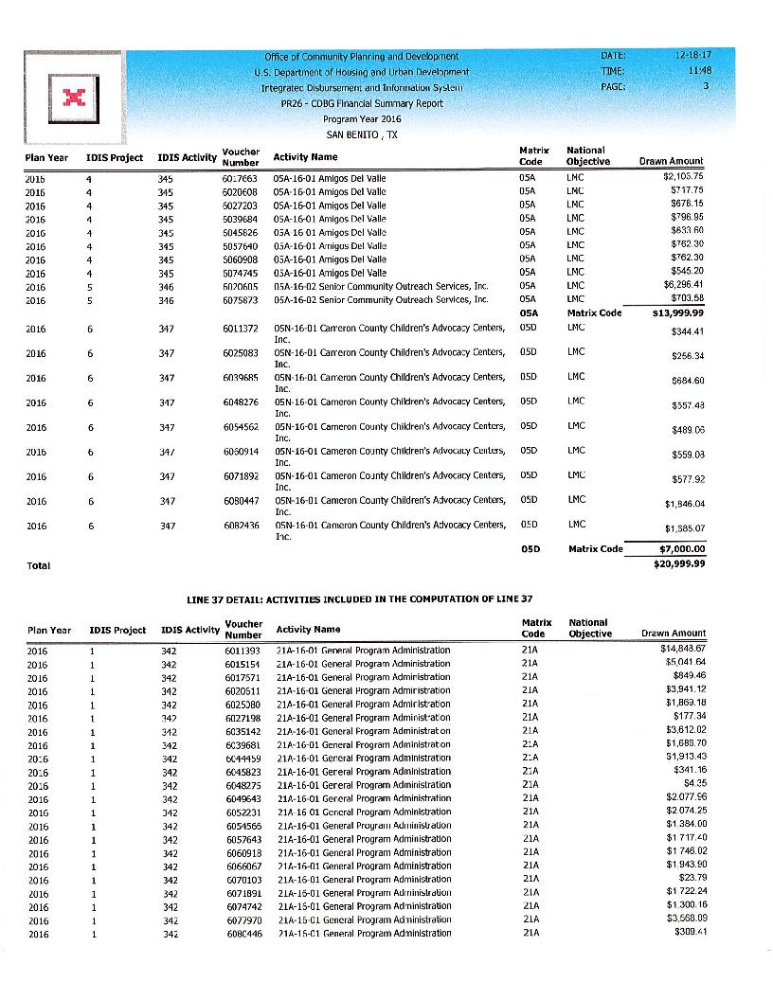


Public Notice and Affidavit
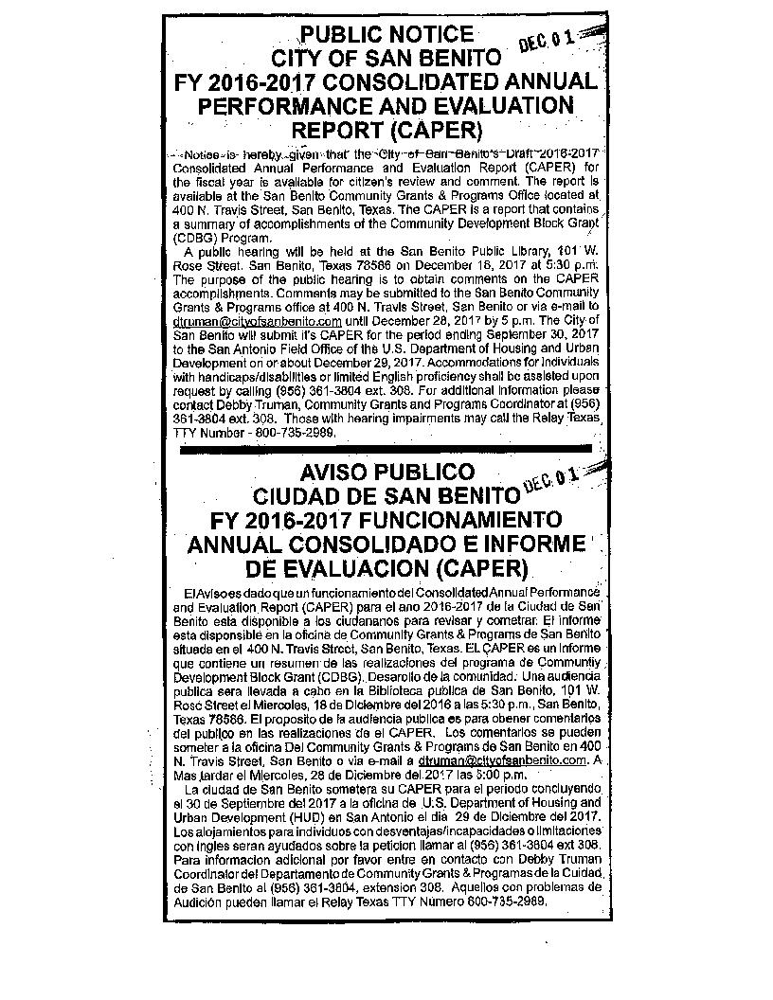
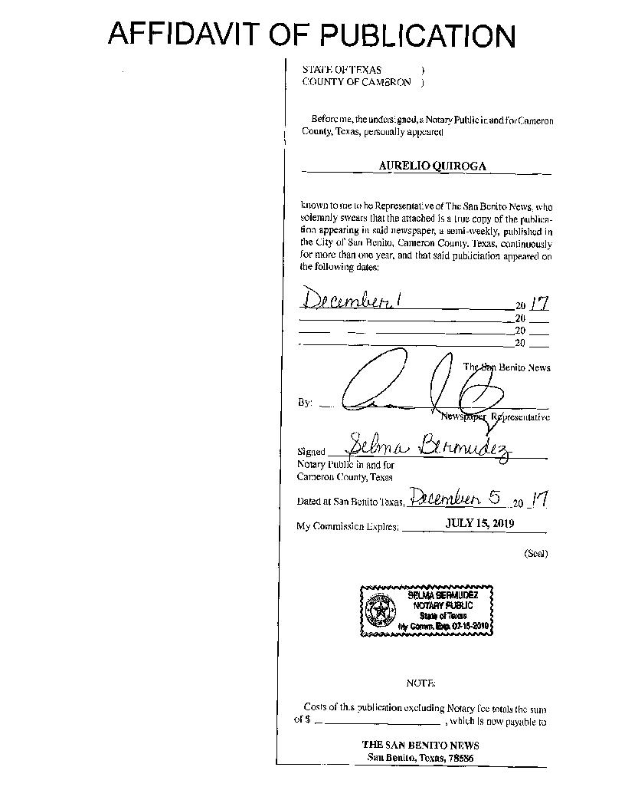

Census Map
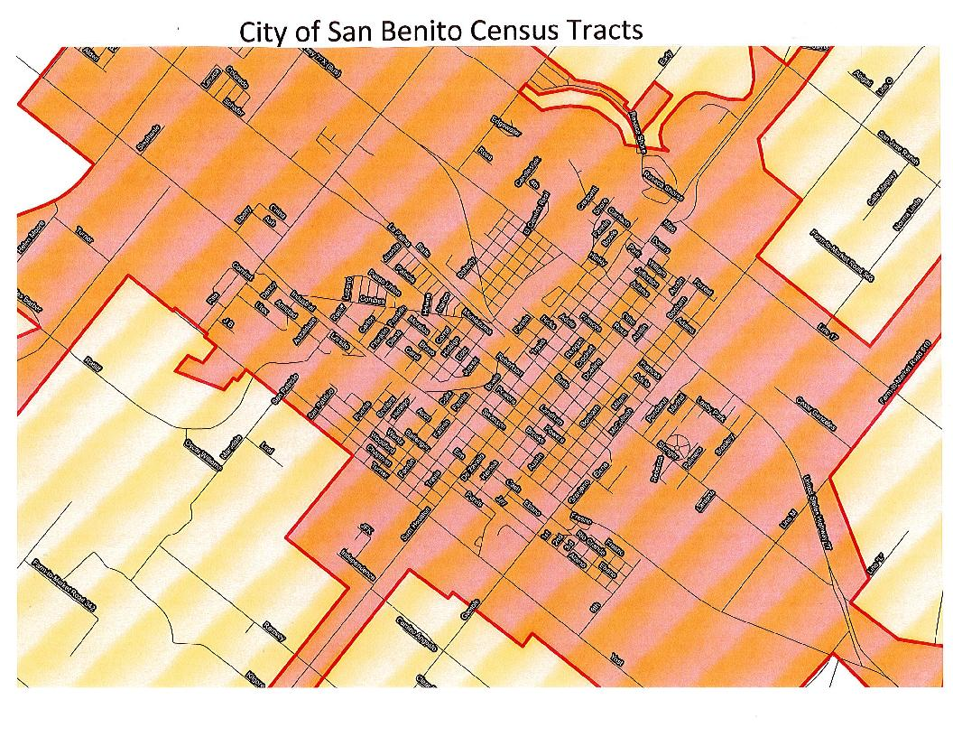

Cameron County Homeless Partnership Strategies
