CITY OF SAN BENITO Press Release

CITY OF SAN BENITO, TEXAS 78586 956-361-3800 i www.cityofsanbenito.com

July 2, 2019 For more information, please contact Martha McClain at 956-361-3804 Ext. 301

For Immediate Release

Historic legislation to initiate new San Benito growth
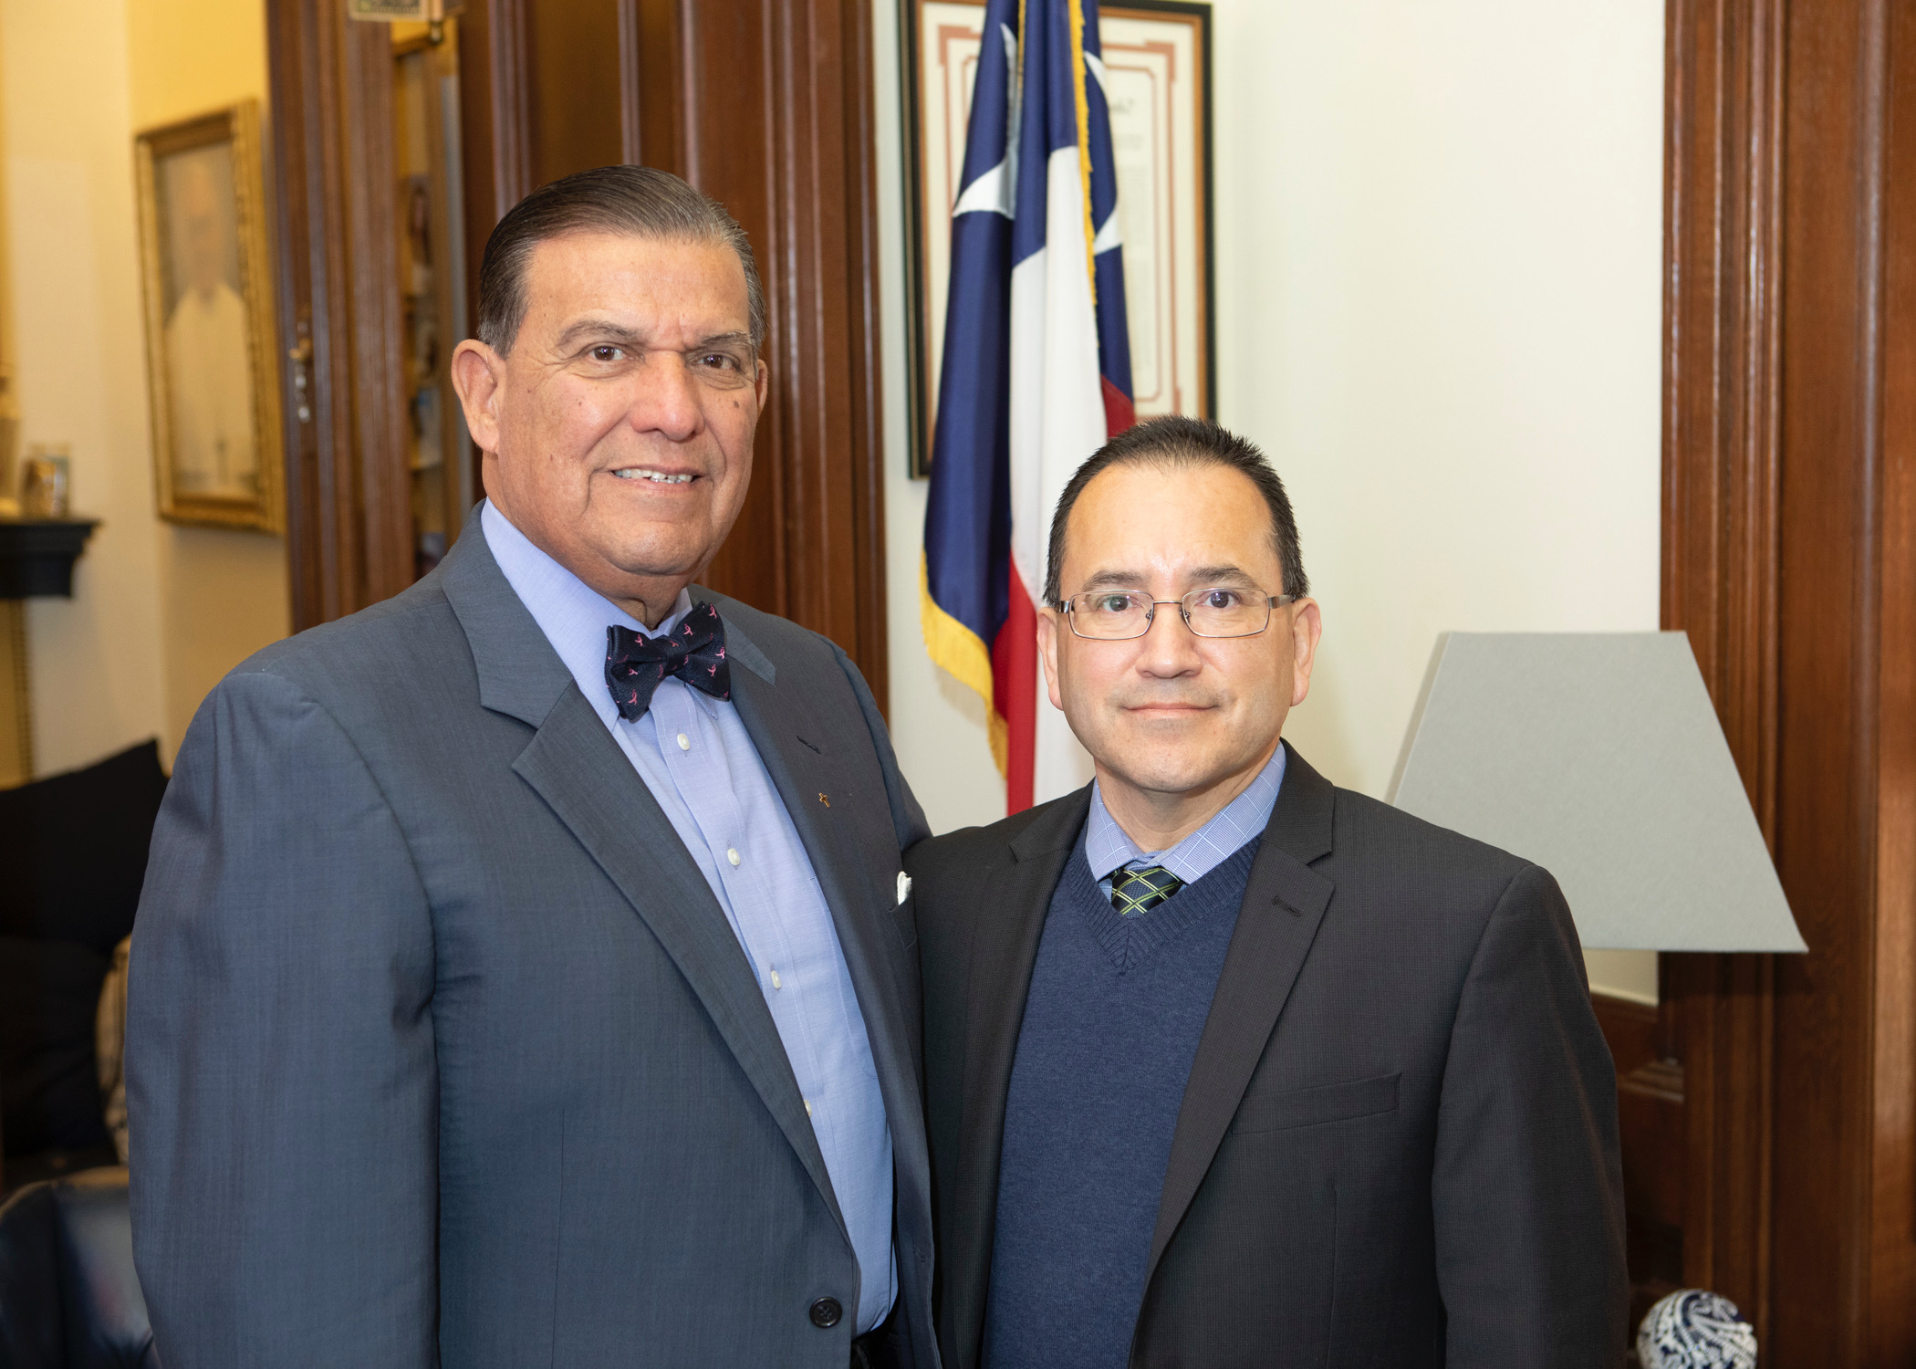
SAN BENITO – City leaders here are excited over newly enacted legislation designed specifically to bring greater growth and development to this community.
“We are ecstatic that after seven long months of hard work and dedication we now have a solid strategy to create new business opportunities in our community,” Mayor Ben Gomez said.
NEW LEGISLATION
“Two newly enacted pieces of legislation resulting from the 86th Legislative Session, House Bills 4377 and 2199, will facilitate financial mechanisms to bring about a variety of retail, sporting, dining, lodging, entertainment and educational facilities to San Benito, according to City Manager Manuel De La Rosa. “This is legislation of historic proportion for San Benito and South Texas,” he added.
State Sen. Eddie Lucio Jr. and San Benito City Manager Manuel De La Rosa.
“House Bill 2199 is designed to use municipal hotel occupancy tax revenue in certain municipalities, including San Benito, for development of sports and entertainment facilities,” he said.
“Likewise, HB 4347 is a bill that will allow San Benito to again use municipal hotel occupancy tax revenue for hotel and convention center projects and other qualified development,” he added.
State Sen. Eddie Lucio Jr. and State Rep. Eddie Lucio III authored and introduced legislation that evolved into the final bills ultimately approved by the Legislature on May 23. “As initial authors of our legislation in their respective chambers of the Legislature, they oversaw the measures through their respective committees and hearings,” De La Rosa said. The legislation becomes effective on Sept. 1.
(Please see next page)

THE PROCESS
“The just completed 86th Texas Legislative Session was very good for the City of San Benito,” the city manager said.
“The Legislative delegation from the Rio Grande Valley was strong this year. They managed to maneuver the bills to the right people. This is wonderful beyond measure for the imminent development of the City of San Benito. With this action, we made it over the goal-line,” De La Rosa added.
“We owe a special debt of gratitude to our State Sen. Eddie Lucio Jr. who worked diligently in the Senate, Rep. Eddie Lucio III, who was tireless in his sponsorship of the legislation in the House of Representatives, and veteran Legislative Consultant Parker McCollough, senior vice president of Mercury LLC, a leading global, bipartisan public strategy firm who helped direct the measure thorough the legislative process,” De La Rosa said. “It is through their perseverance that these two major pieces of legislation were enacted,” he added.
HOW IT STARTED
Approval of the legislation comes after nine months’ work of intense work by City and State elected officials who were instrumental in guiding the Bill through the Legislature, said De La Rosa. In September 2018, the concept arose when a developer approached the city manager to propose a project similar to one he has underway in East Texas, utilizing municipal hotel funds as incentives to pay-down development costs. “He liked our physical location with traffic flow to the north and south, and the availability of land. The problem was, we needed to change state law to be able to assist in financing the anticipated multi-million project. It was quite a challenge for us to decide to tackle this mammoth undertaking. You know how difficult it is to actually pass a law, so, it is quite amazing that we were able to get this accomplished on our first try,” De La Rosa said,” he said.
The City Commission in October 2018 agreed to hire McCollough as their legislative consultant, who is a former legislator himself, with knowledge and contacts that were instrumental in the success of the proposed legislation. Hard work, long hours by all concerned and a die-hard spirit were instrumental in its success, the city manager said.
On Jan. 22-24, the city manager met in Austin with the senator and representative to discuss the proposal and seek their support in filing bills that would accomplish the goals needed to advance the project. Then, from April 8-10, De La Rosa met again at the State Capital with key legislators seeking support of the measures and also testified before the Senate’s Intergovernmental Relations Committee and the House Ways and Means Committee.
Efforts culminated on May 23 when the bills crossed the legislative “finish line,” he said.
WHAT’S NEXT
With the legislation approved, the City begins the process of establishing legal agreements with potential developers.
The legislation that has the potential of furthering San Benito’s reputation as a “Destination City” will help attract a greater number of visitors from both Mexico to the South, and throughout the State of Texas, thereby making the city an international destination,” the city manager said.

--30--

